University of Rochester

Electrical and Computer Engineering

Lab #3

Superposition

**Objectives**

The purpose of this lab is to verify the principle of Superposition. This is the idea that the output of a linear circuit due to multiple independent inputs is equal to the sum of the outputs due to each input taken separately.

**Procedure**

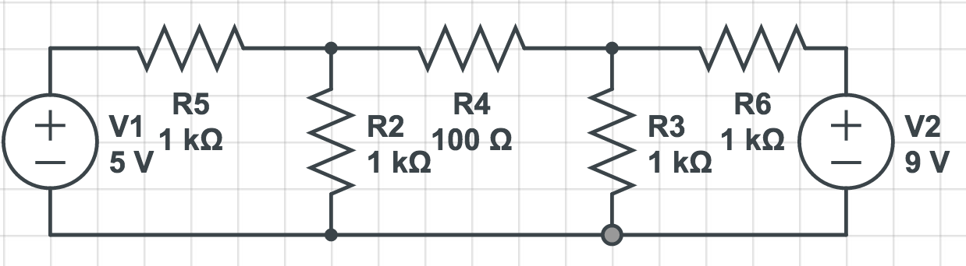

First, we theoretically analyzed the circuit that we would be measuring to get the voltage across the 100Ω resistor. Through Node Voltage Analysis, we found the voltage across the 100Ω resistor, VO to be 182 mV.

Then we built the circuit and did some analysis. We measured the voltage across the 100Ω resistor while both voltage sources were one, and then when either one of them was turned off. We were also asked to calculate the gain of the output for both of the voltage sources separately.

When both of the power supplies were turned on, we read that the output voltage was 179mV. When only the 5V supply was on, we measured the output to be 224.6 mV. When only the 9V supply was on, we measured the output to be 403 mV. The gain for the 5V and 9V power supplies were about 1/20 and 2/45, respectively.

While measuring the individual sources, we made sure to measure the voltage with the anode on the positive side of the resistor for both sources. Algebraically, this is inconsistent, because if we measured both voltages across the 100Ω resistor in the same way, the results for the 5V power source would be negative. Therefore, if we add the outputs of our two voltage supplies algebraically, then we get an output of 179mV. This matches our result and shows that superposition works.

Then, we predicted the results of the output voltage if the 5V power supply was changed to a 9V. Our theoretical result is that the voltage difference will be 0V. Our measured result was that the output was equal to 2.2mV, which is nearly 0 and well within acceptable error.

**Executive Summary**

Superposition is the idea that the output due to multiple voltage sources in a linear circuit is equal to the algebraic sum of each other their outputs individually. This report does a theoretical and practical analysis of a linear circuit with multiple voltage sources to verify this idea. First, we did a theoretical voltage analysis of the circuit with both sources on and with each one on individually. Then, we built the circuit and measured the three outputs. The theoretical analysis and practical analysis both show that the outputs of the voltage sources individually add to equal the output of the voltage sources together. These results show that the idea of superposition works.